Name: Saurabh Sanjay Jadhav

Topic : VPC peering(Same region peering & Different region peering).

Assignment no. : 20

1. Create a VPC network in virginia region.
2. Create VPC

Name : vpc-virginia

CIDR : 10.0.0.0/24

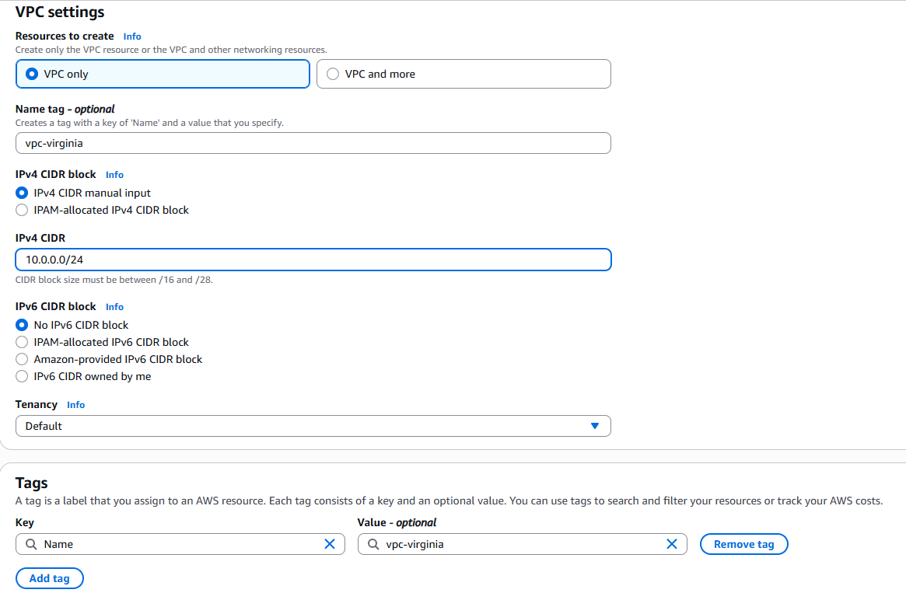

1. Create a subnet.

Name: subnet-1

CIDR: 10.0.0.0/27

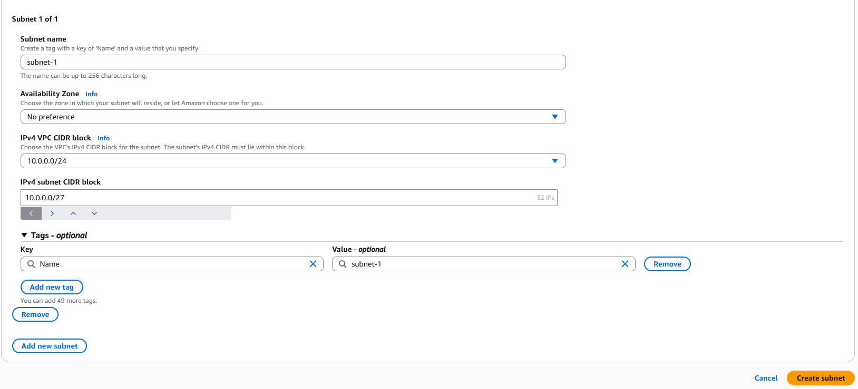

1. Create internet gateway for vpc.

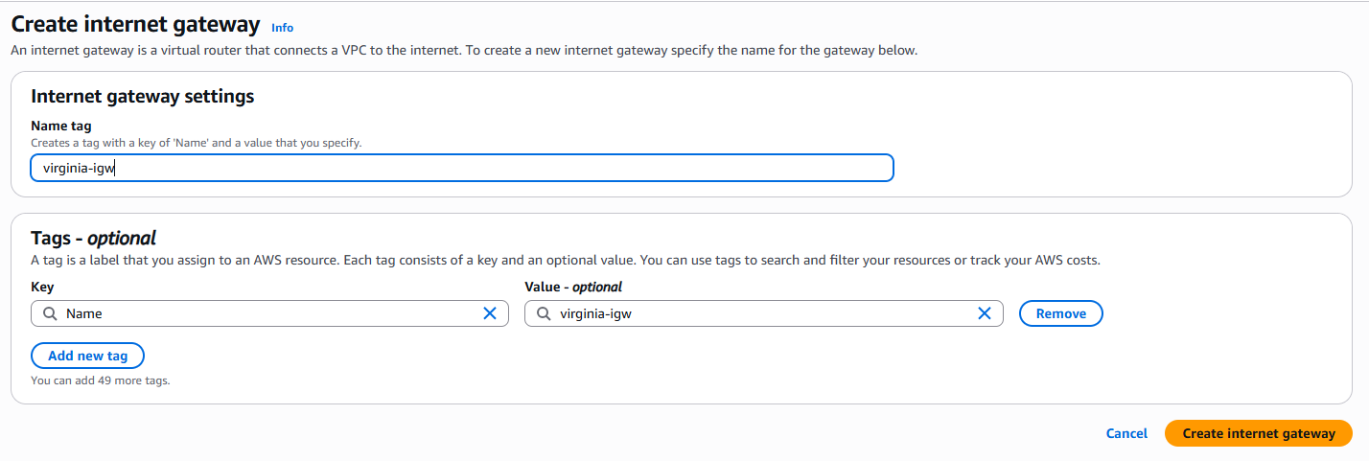

Attach IGW to vpc.

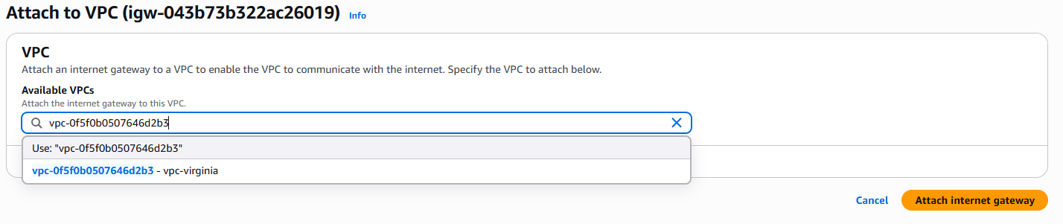

1. Create route table.

Add subnet association to subnet-1.

Add route to internet gateway.

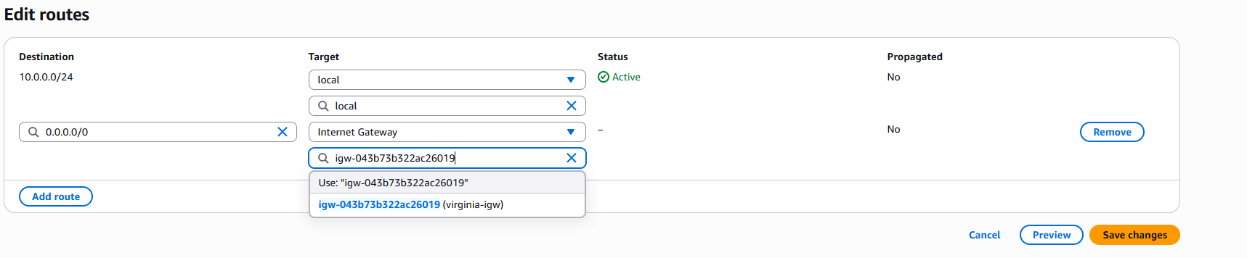

1. Create VPC in another region i.e. Mumbai region.
2. Create vpc

Name : vpc-mumbai

CIDR : 192.168.0.0/24

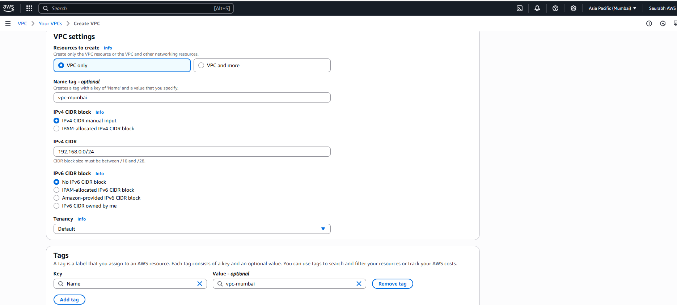

1. Create subnet

Name : subnet-1

CIDR : 192.168.0.0/27

1. Create internet gateway and attached it to vpc in Mumbai.

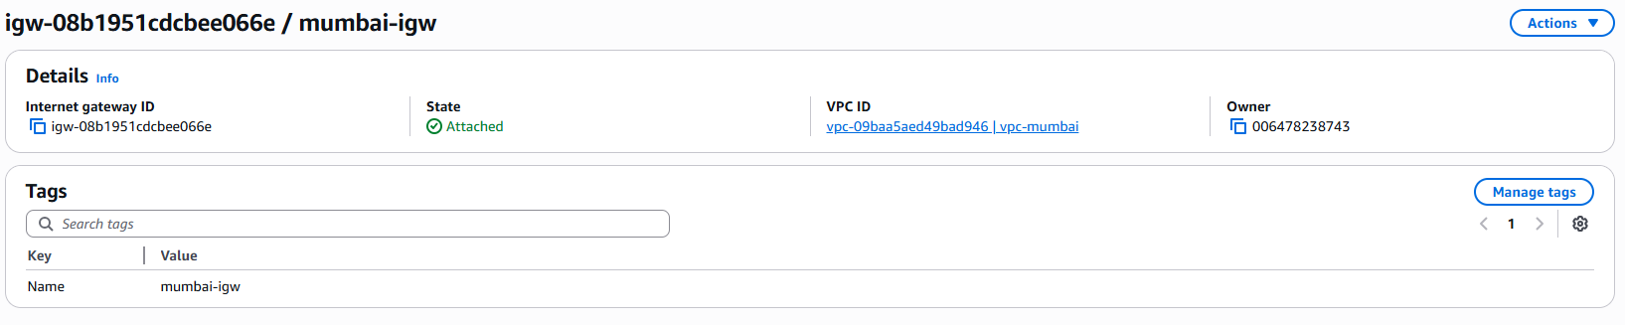

1. Create route table , associate subnet and add route to igw.

1. Create VPC peering in virginia region.

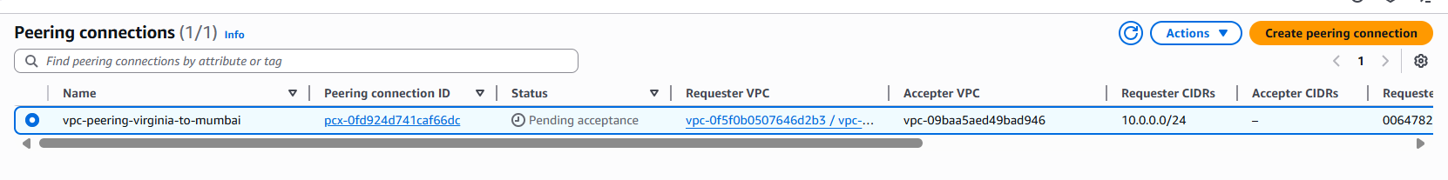

Accept the peering request in Mumbai region.

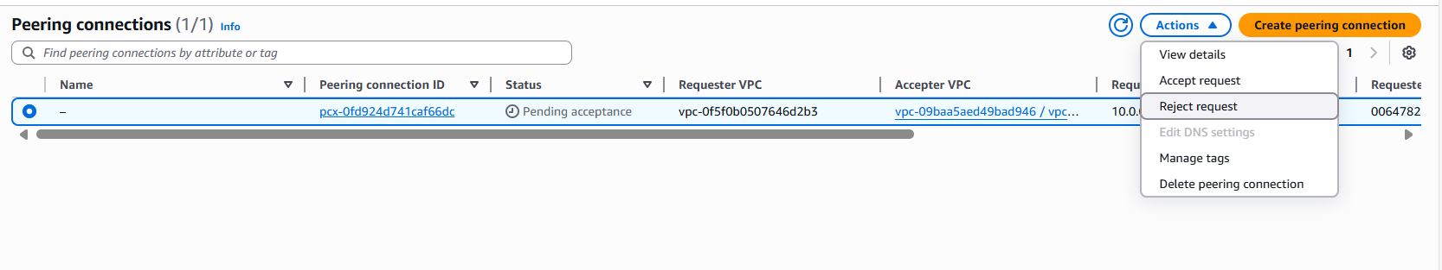

1. Add routes of vpc peering in route table of both regions.
2. Virginia-rt: destination – 192.168.0.0/24, target- select peering conn.

1. Mumbai-rt : destination – 10.0.0.0/24, target – selectpeering conn

1. Create EC2 instance in virginia region.

Name : virginia-instance

Create new key pair : virginia-key-pair

Select vpc network : vpc-virginia and its subnet also enable assign public IP

Allow all traffic in security group.

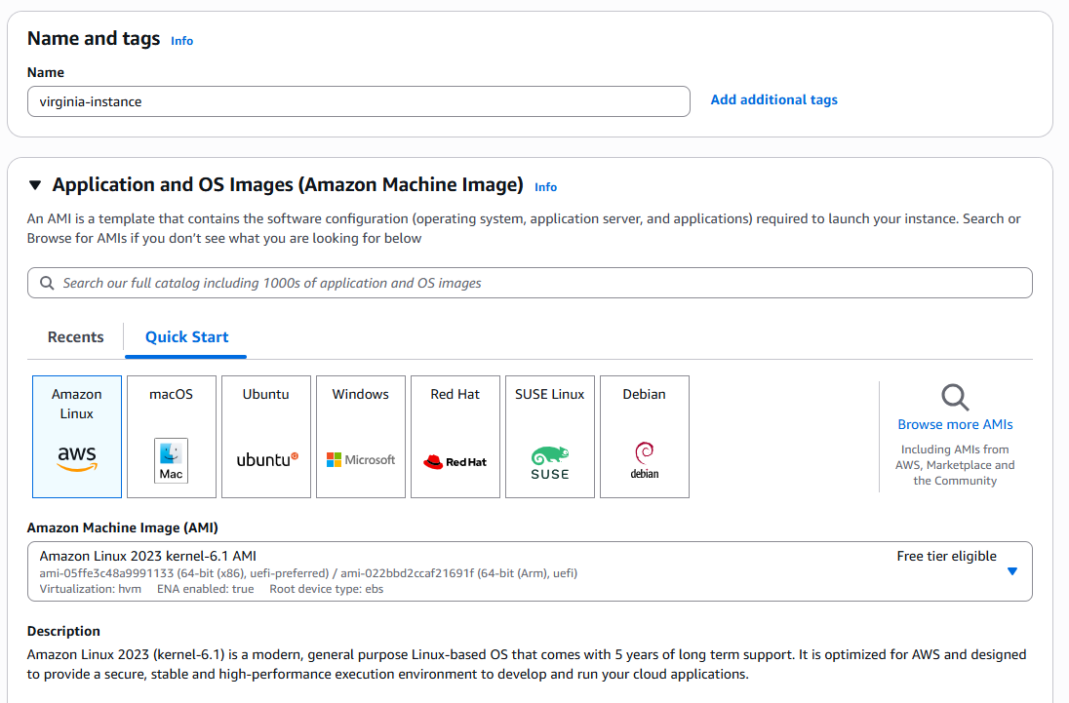

1. Create EC2 instance in Mumbai region.

Name : mumbai-instance

Create new key pair : mumbai-key-pair

Select vpc network : vpc-mumbai and its subnet also enable assign public IP

Allow all traffic in security group.

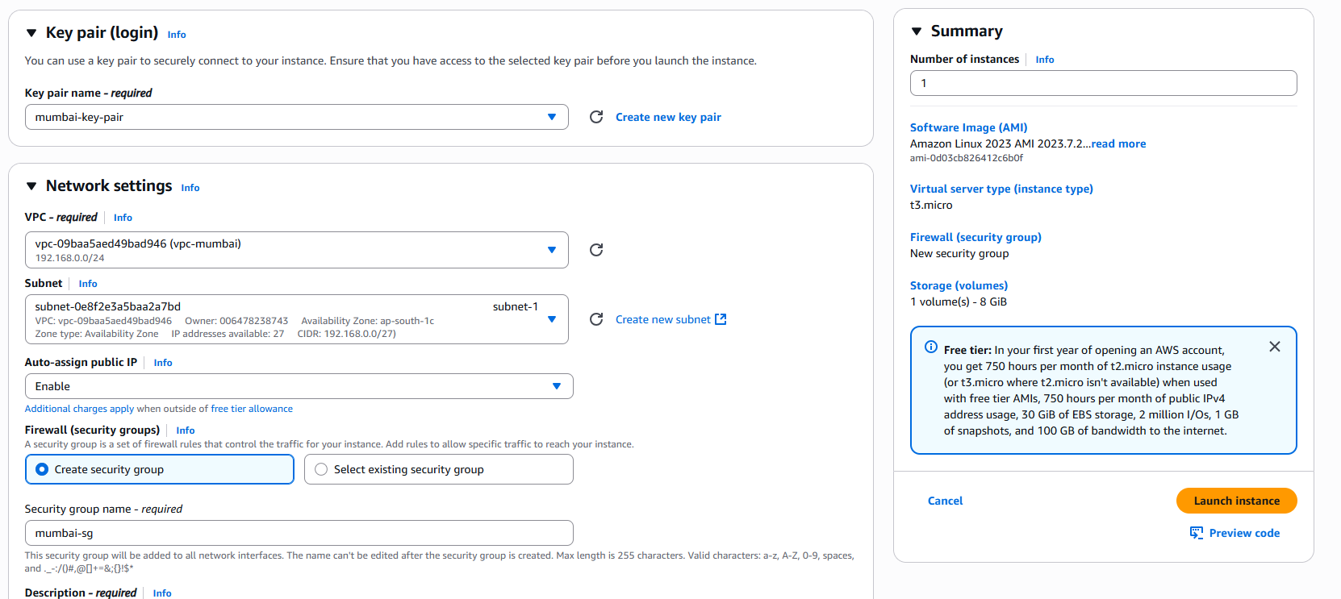

1. Successful connection from virginia region instance to Mumbai region instance.

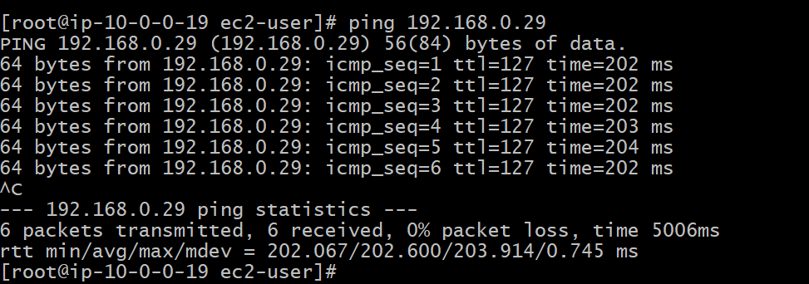

1. Successful connection from Mumbai region instance to virginia region instance.

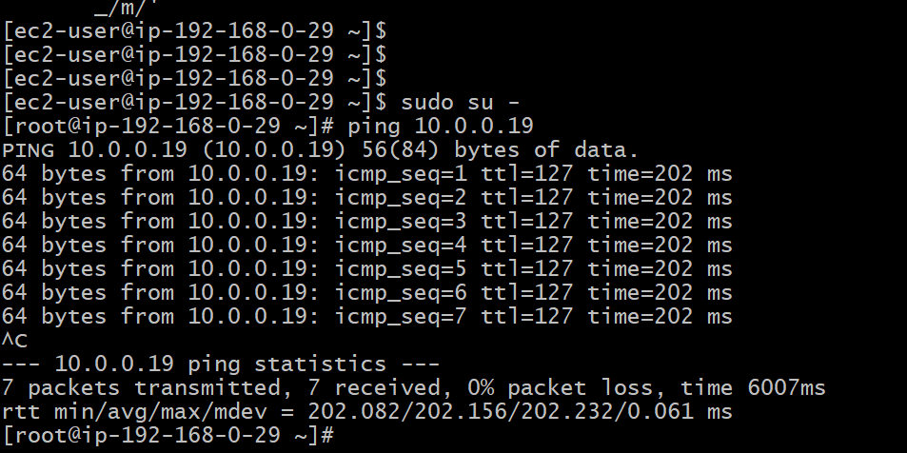

**Same region VPC peering**

1. Follow the steps of virginia region to create vpc network and EC2 instance and create 2 VPC and 2 instances.
2. Second vpc network in virginia region.

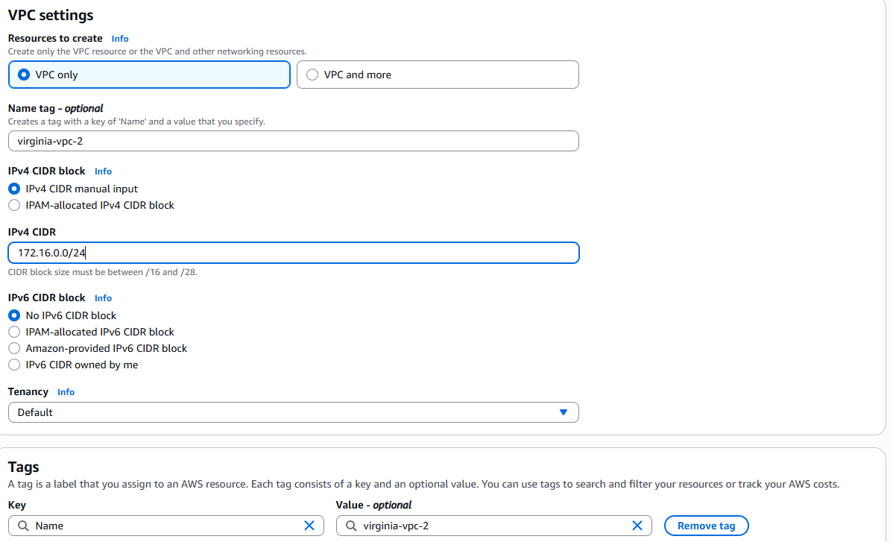

2 VPC created

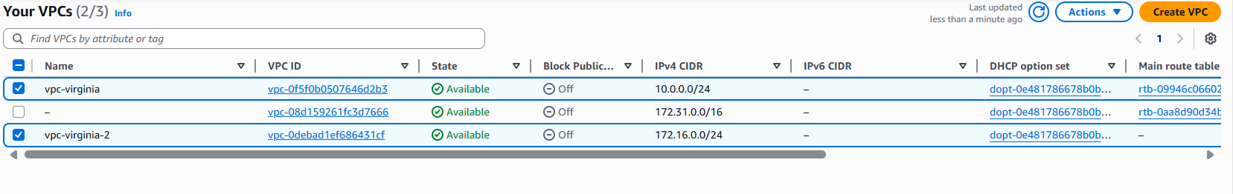

1. Create subnet, IGW for vpc-virginia-2.
2. Subnet:

Name:subnet-2

CIDR : 172.16.0.0/27

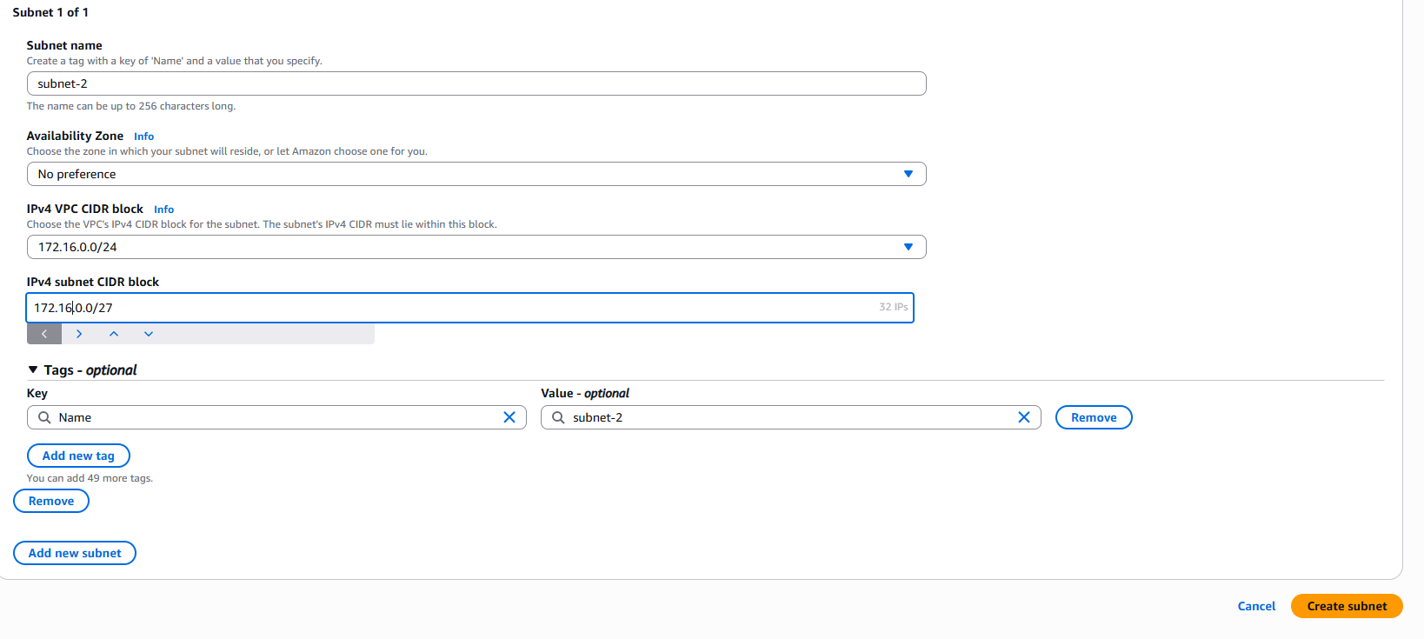

1. Internet gateway

Name : virginia-igw-2 and attach it to vpc-virginia-2

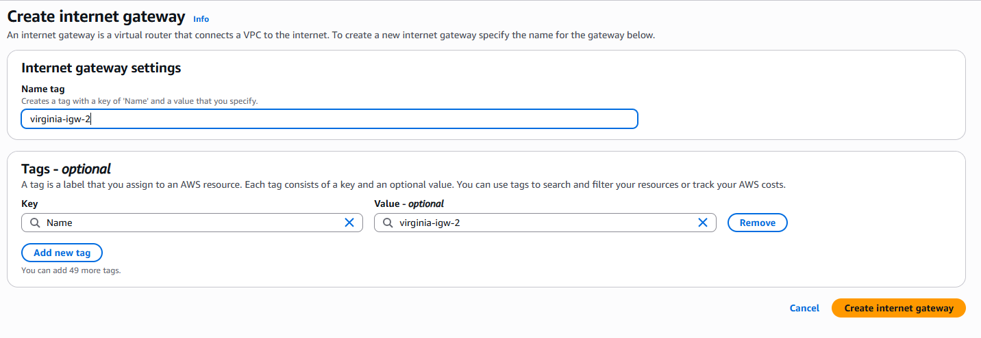

1. Route table:

Name: virginia-rt-2

Add route to internet gateway

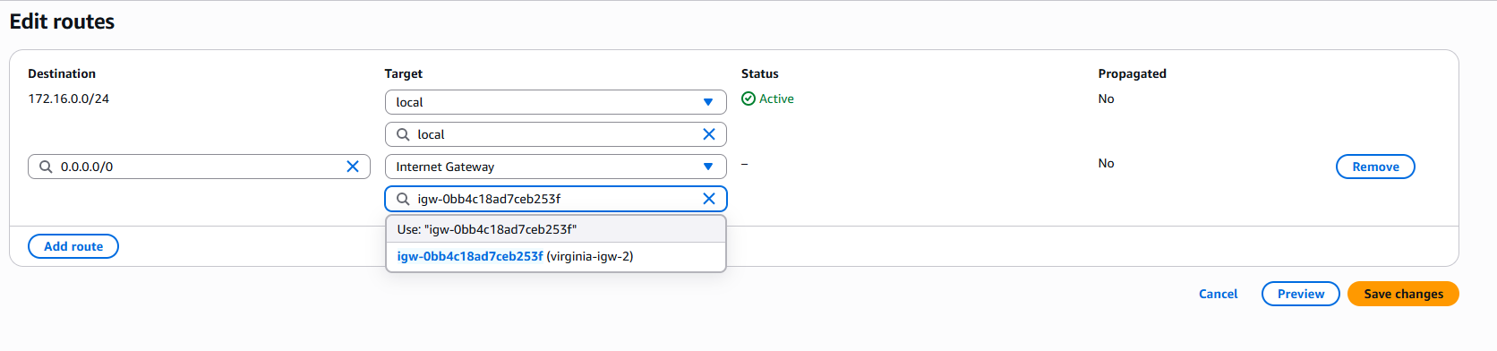

Subnet association to subnet-2

1. Create peering connection.

Name : same-region-peering

Requestor: vpc-virginia

Acceptor : vpc-virginia-2

1. Accept the request in vpc-virginia-2 peering connection.

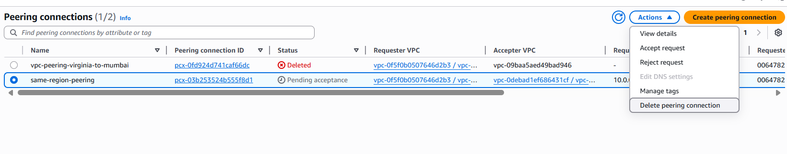

1. Add routes to peering connection in route tables of both vpc’s.
2. Virginia-rt :

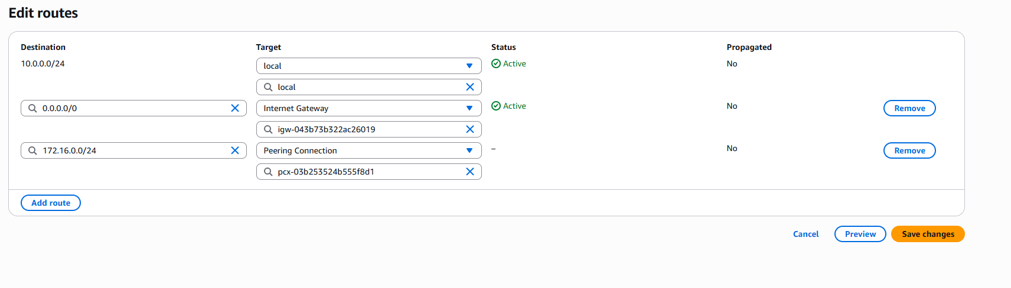

1. Virginia-rt-2:

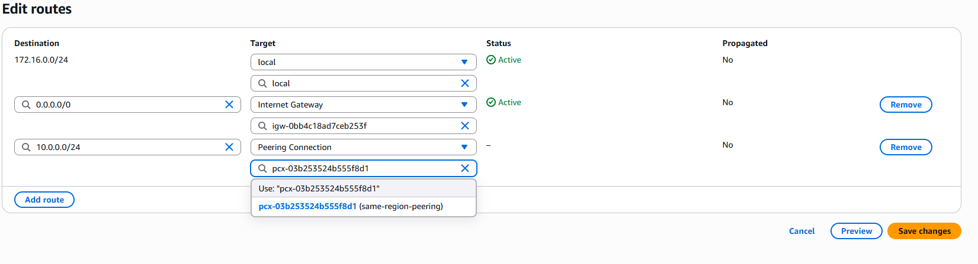

1. Create EC2 instance in both vpc.
2. In vpc-virginia:

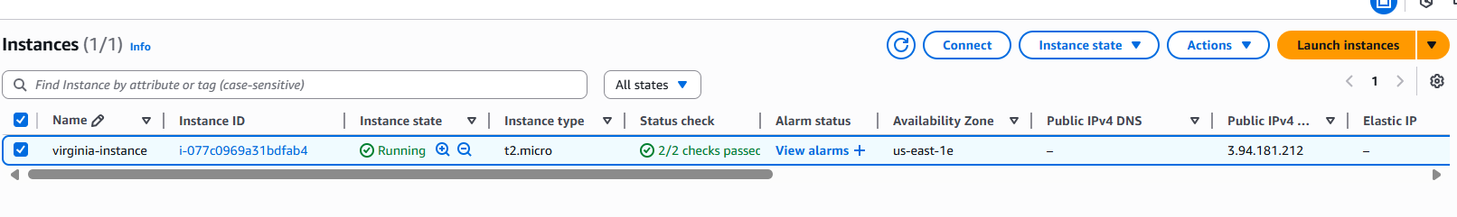

1. In vpc-virginia-2:

1. Check vpc peering.
2. Successful connection from virginia-instance to virginia-instance-2

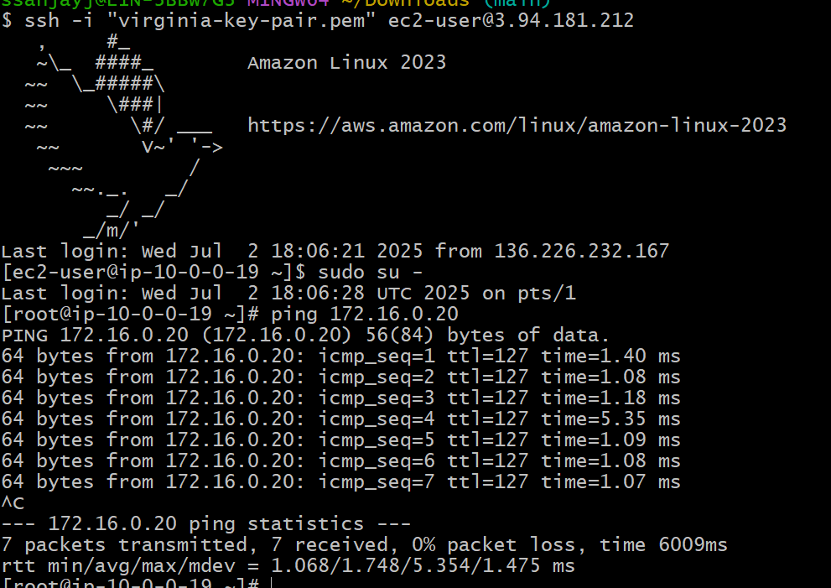

1. Successful connection from virginia-instance-2 to virginia-instance

